Hough_Grd(imgfltrd, 6, 0.3); Hough_Grd(imgfltrd, 6, 0.1);

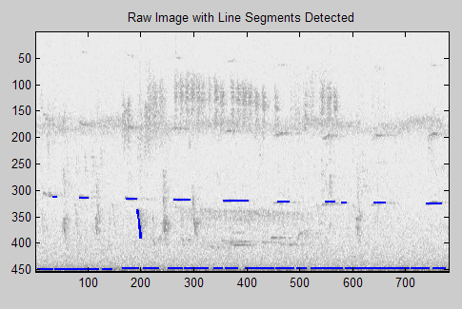 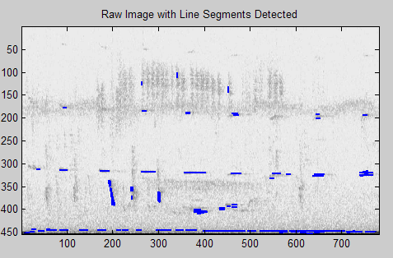

Hough_Grd(imgfltrd, 6, 0.05);

